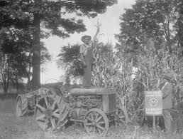

Registration

Which Session will you attend? Circle One: 9:30 AM or 12:30 PM

Name_______________________________________________________________________________________

Preferred Contact method:  
  
Email_______________________________________________________________________________________

Or

Phone_______________________________________________________________________________________

What are you most interested in learning?______________________________________

This is a resource and fun filled workshop. You can register by email, phone, or mail.

Paul Revere couldn’t have asked for more.

By email: Return this form to [Dorothy@itsnevertoolate.com](mailto:Dorothy@itsnevertoolate.com)

By phone: Call 253-582-4565, leave your name and return number

By mail: send form to PO Box 881, DuPont, WA 98327

Cost of workshop: $5, which covers materials and free ticket to the Ice Cream Social payable at the door..

Enrollment is limited.

S

**How to Write About the Nuts**

**and Nuggets**

**In Your Family History**

**With**

**Dorothy Wilhelm**

**&**

**Val Dumond**

**Aug 24, 2013 at DuPont Community Center**

**9:30 – 11:00 AM 12:30 - 2:00 PM**

**$5 includes materials**

So glad you can come! All Proceeds go to the DuPont Historical Museum

**Shake Up Your Family**

**Tree**